Track Day Tire Data Sheet

Bulldogs Racing
BR2016

Car Name: ___________ Date: __________ Time: __________ Ambient Temp: __________

Competition: _________ Event: _________ Temp Time: _____ Pressure Time: ___________

Pressure Order: Left front, Left rear, Right rear, Right front, Left front
Temperature Order: Right front, Left front, Left rear, Right rear, Right front

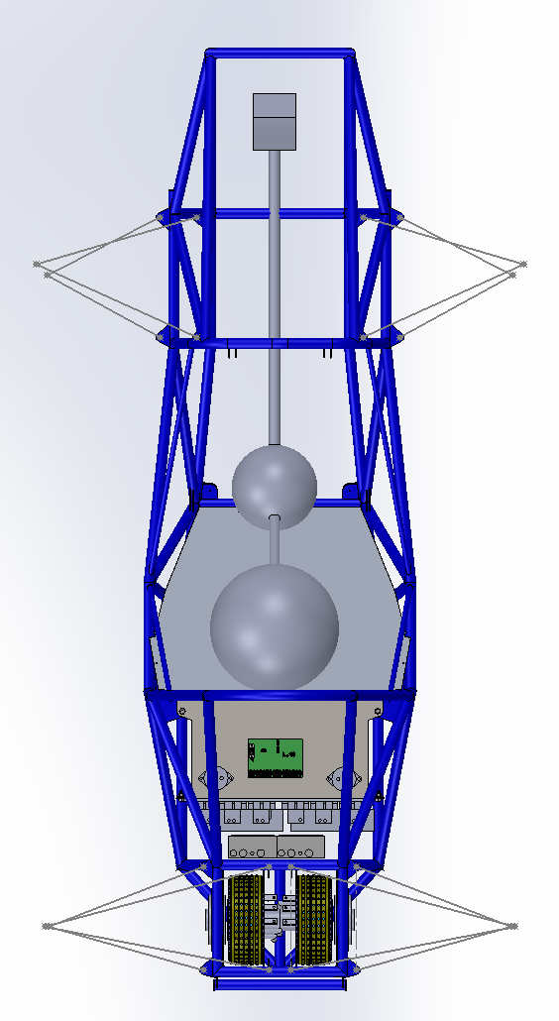

Left Front Tire Right Front Tire

Tire ID: ____________ Tire ID: ____________

Cold Pressure: _______ Cold Pressure: _______

Hot Pressure: ________ Hot Pressure: ________

________ Temps (in, mid, out):

Temps (out, mid, in): ______ ______ ______

______ ______ ______ ______ ______ ______

Left Rear Tire Right Rear Tire

Tire ID: ____________ Tire ID: ____________

Cold Pressure: _______ Cold Pressure: _______

Hot Pressure: ________ Hot Pressure: ________

Temps (out, mid, in): Temps (in, mid, out):

______ ______ ______ ______ ______ ______

